**All Overlays in random mode:**

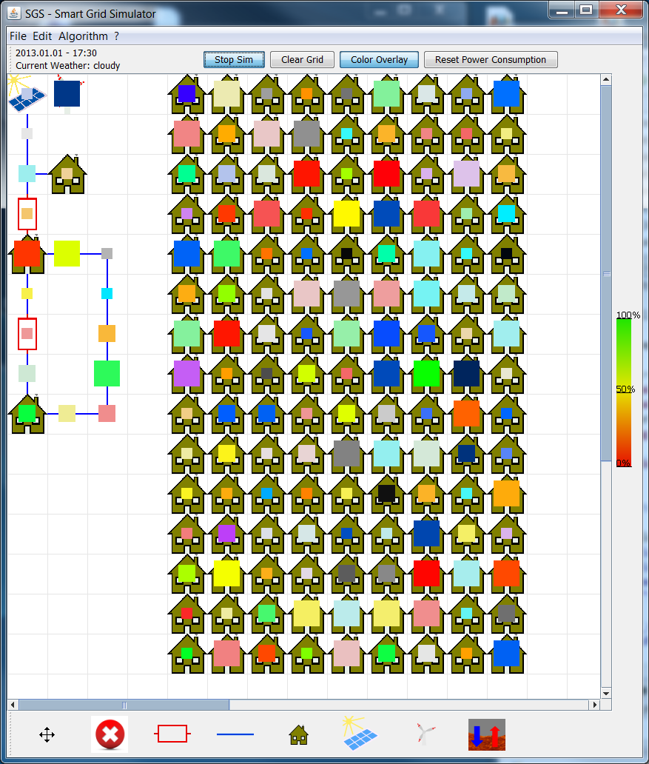

**Black to white:**

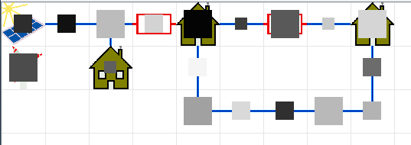

**Green to red:**

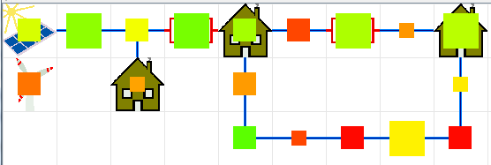

**Blue to black:**

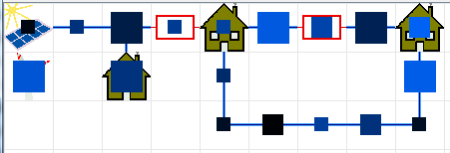

**Other Overlays:**

Single colors: From slight gray to color.

Red to Green to Blue.